

Project Code : | BITU 2913

UNIVERSITI TEKNIKAL MALAYSIA MELAKA
FACULTY OF INFORMATION AND COMMUNICATION TECHNOLOGY

WORKSHOP 1 PROPOSAL FORM
[Incomplete form will be rejected]
A | TITLE OF PROPOSED PROJECT:
 | Tajuk projek yang dicadangkan : Hotel Management System
 | Project Domain:
 | Domain Projek:
 |  | BUSINESS & SERVICES |  | HEALTHCARE |  | TRANSPORTATION |  |  | COMMUNITY SERVICESS
 | : | AUTOMOTIVE |  | AGRICULTURE |  | OTHERS :
B | DETAILS OF STUDENT / MAKLUMAT PELAJAR
B(i) | Name of Student: Identity card no.:  Nama Pelajar:No. Kad Pengenalan :Yaseen Mohamed  Student matric no.:  No. Matrik Pelajar : B032220060  Programming Technique (BITP 1113) Grade : Gred Teknik Pengaturcaraan (BITP 1113) :  A A- B+ B B- |  |  |  |  | C+ | C | C- | D
B(ii) | Correspondence Address : Ayer keroh , The heights residence  Alamat Surat Menyurat :
B(iii) | Course:  Kursus:  BITC |  | BITZ | BITE | BITI |  | BITM |  | BITS | BITD
B(iv) | Home Telephone No.:  No. Telefon Rumah:  Handphone No.: 0167084608  No. Telefon Bimbit:

B(v) | E-mail Address: B032220060@Student.utem.edu.my  Alamat e-mel:
C | PROJECT INFORMATION / MAKLUMAT PROJEK
C(i) | Duration of this project:  Tempoh masa projek ini:  Duration: 14 WEEKS  Tempoh :  From : 09/03/2024  Dari :  To : 14/06/2024  Hingga :
C(v) | Executive Summary of Project Proposal (maximum 300 words)  (Please include the background of project, problem statements, objectives, scope and project significance from the project)  Title: Hotel Management System  A command-line program called the Hotel Management System was created to improve visitor experiences and expedite hotel operations. It unifies staff management, billing, reservation management, room tracking, and guest services onto a single platform.  Simple booking procedures, effective capacity monitoring, expedited receipt of payments, task delegation, and customized visitor experiences are among the notable advantages. Robust reporting are also provided by the system.  Benefits include cost savings, capacity, and greater efficiency. The system offers hoteliers an easy-to-use interface for efficient operation management.  Ringkasan Cadangan Eksekutif Projek (maksima 300 patah perkataan)  (Meliputi latar belakang projek, penyataan masalah, objektif dan kepentingan projek)
C(vi) | Detailed proposal of project:  Cadangan maklumat projek secara terperinci:  - Project background including Introduction and Problem Statements  Keterangan latar belakang projek termasuk pengenalan dan penyataan masalah.  - Introduction:  Efficient hotel operations are vital for great guest experiences and revenue optimization in the hospitality industry. Manual methods for handling bookings, check-ins, check-outs, and billing are prone to errors and inefficiencies. Developing a robust Hotel Management System (HMS) is crucial to streamline operations, automate key procedures, and empower hotel employees to deliver superior guest experiences.  - Problem Statements:  The manual administration of hotel operations poses several difficulties. First of all, it is vulnerable to mistakes, which can result in problems like duplicate reservations, imprecise inventory control, and delays in providing guest service,Also one assigning a room should be automaticlly when the room is booked. Second, without automation, it gets difficult and time-consuming to manage different duties including room assignments, guest check-ins and check-outs, housekeeping schedules, and billing.  - Objective (s) of the Project  Objektif Projek  Example /Contoh:  This project embarks on the following objectives:  - To develop and design a comprehensive Hotel Management System (HMS) using C++, That automates key hotel operations such as reservations, check-ins, check-outs, and billing.  - To assess the effectiveness of the HMS in streamlining hotel operations, reducing errors, and enhancing guest experiences.  - To make recommendations based on the evaluation of the HMS, suggesting improvements or additional features to further optimize hotel management processes and maximize guest satisfaction.  - Scope

Skop

- Module to be developed

Reservation Management Module: This module allows hotel staff to manage room reservations, including checking availability, making new reservations, modifying existing reservations, and canceling reservations.

- Target User

Hotel Admin , Staff and Customers , But The primary users of the Hotel Management System (HMS) are hotel employees, including front desk staff, reservation manager, And billing personnel. These users will utilize the system to efficiently manage hotel operations and provide excellent service to guests.

- Problem Decomposition Description
Deskripsi Penguraian Masalah

- Reservation Management: Break down tasks into checking availability, creating, modifying, and canceling reservations.

- Check-in and Check-out Process: Decompose into guest registration, room assignment, key issuance, payment processing, and room status updates.

- Inventory Management: Decompose tasks into tracking availability, managing room types, allocations, and amenities.

- Billing and Invoicing: Break down into calculating charges, generating invoices, processing payments, and maintaining records.

- Structured Chart
Carta Berstruktur
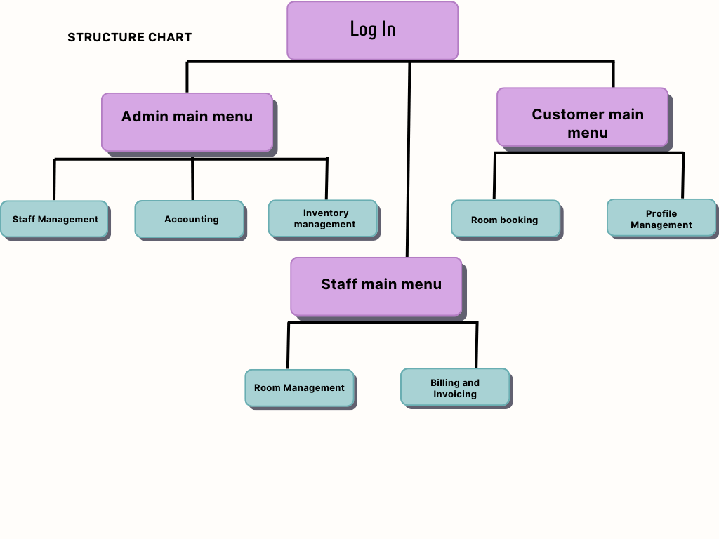

- Project Significance
Kepentingan projek

- Improved Guest Experience: Streamlined processes lead to smoother check-ins and better guest satisfaction.

- Operational Efficiency: Computerized system reduces errors, optimizes resource use, and boosts staff productivity.

- Scalability and Adaptability: The system can easily adapt to industry changes, ensuring long-term sustainability and growth.

Carta Gantt Aktiviti Projeck:
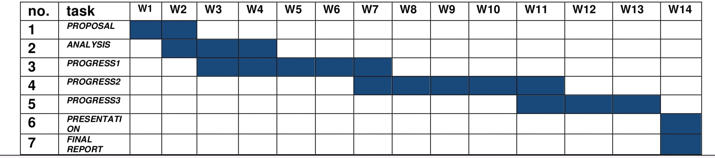
D | REFERENCES
State your references:
- Programming Technique (BITP 1113)

- Data structure and Algorithims (BITP 1123)

- DataBase (BITP1323)
E | ACCESS TO EQUIPMENT AND MATERIAL (PLEASE LIST IN DETAIL) / KEMUDAHAN SEDIA ADA UNTUK KEGUNAAN BAGI PROJEK INI (SILA SENARAIKAN DENGAN TERPERINCI)
 | University  Universiti | Other Sources or Places  Lain-lain tempat/sumber
Example / Contoh:

Software:

ER Assistant, Microsoft Visual C++, Microsoft Visual Basic, Microsoft Access

F (i) | Declaration by student/ Akuan Pelajar
Date : 20/3/2024 Student’s Signature :
Tarikh : Tandatangan Pelajar :

